Trump Wins- The Battle Begins
November 10, 2016
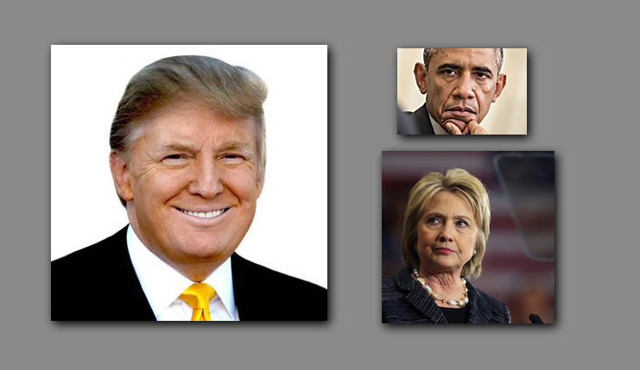
May the Lord’s joy be with you all, Heartdwellers.

What a tremendous victory! I heard from one source that the day he is sworn in he will be 70 years 7 days and 7 hours old! Amazing!

Jesus began, “My arm has never been short. I will accomplish what I have set out to do, but it will require the prayers of My People. Dear ones, the fight is only just beginning. The tentacles reach deep beneath American soil and it will be a long, hard battle to restore America and set her upright on her feet.

"The brainwashing of the young has had a significant affect in causing division and will continue until the truth is exposed about those who have won their hearts. Personality is everything. Women’s rights, immigration policies, all figure strongly in the aftermath.

"My dear ones, though this man seems a blustering fool on the surface, he did not come about his fortune being ignorant of men’s ways. He cares deeply about his country, and has My vision for restoration. Though some of the measures seem harsh to foreigners, this country is so fragmented and infiltrated by the Muslims that these measures are very necessary. Yet the tentacles run deep.

"What I need from all of you is daily prayer that he will make the decisions I want him to make and that he will walk softly with his big stick. He has much PR work to do to reunite the nation. Rest assured that those that pose as affirming friends are deadly enemies and will stoop to do anything to cause chaos in this country.

"Just as you prayed for peace at the convention, I need you to pray the very same way for this transfer of authority and all the organized demonstrations. Yes, they are organized and deliberately fomenting division and separation. This can be defeated by prayer. I am asking you to pray.

"My beautiful Bride, the future of this nation hangs in the balance until President elect Trump has been in office for two years. So, please be vigilant to pray for peace in this nation every day.

"My heart for you all is to prosper in your love and giftings that all men may come to know Me. If each of you will shoulder your cross and responsibilities to your calling, you will be rewarded beyond your wildest dreams.

"A nation needs to live in peace for it to prosper, and you have seen the devastating affects of ignoring those who have led this country. Many of you suffer from the sins of this nation, which I have allowed because of her abominations to third world countries and the training of radical mercenaries on this soil, as well as abortion and world population control through manipulating the natural rhythms of the Earth, which I created so all men could be nourished from the land.

"As America goes, so goes the world. There is a great chance of reversing the tide of evil that could have made possible the predictions in Daniel, the AntiChrist’s one world government, coming to pass much sooner."

And here I want to make an aside. Here, He's not saying that Daniel's not going to come to pass. He's saying it IS going to come to pass, but it's being delayed because of our prayers.

Jesus continued, "As you pray, I dismantle key situations making it impossible for them to be carried out. You do not see what I am doing behind the scenes but you do see the affects - such as Donald Trump being voted into office, and America succeeding in even having elections when there was a plan underway to stop that from happening. But because of your prayers, it didn’t succeed.

"This is My power, dear ones. Believe firmly in My ability and watch Me make the impossible happen consistently. I am doing this so you may move forward, serving and bringing souls to Me.

"And one last word of caution, do not get drawn into these fomenting political demonstrations which will be used to divide the country and cause civil war.

"This may seem far-fetched to you, but you are not looking at what is behind the scenes of these demonstrations. You are seeing them as only a surface manifestation of people’s discontent. Taking a closer look, there are plans to disrupt the country’s stability, even giving an excuse for martial law, as the evil one capitalizes on people’s emotions.

"Do not take part in these. Rather go to your knees and pray that I will disarm them.

"I wish to hold you tenderly, dear ones. I wish to comfort and encourage you. I am so very sorry that you must deal with these situations in order to bring souls to Me, but this is part of your responsibility as My Bride.

"Understand that although My disciples did not get involved in political issues, these times are different. You are living in a democracy, and what you cast a vote for impacts your life. When you support those who condone abortion, you are placing a great weight on your own personal shoulders and on your family - as well as guaranteeing judgment on your nation.”

At that point, the Lord began to quote the Scriptures:
First of all, then, I urge that petitions, prayers, intercessions, and thanksgiving be offered on behalf of all men for kings and all those in authority, so that we may lead tranquil and quiet lives in all godliness and dignity. This is good and pleasing in the sight of God our Savior… I Timothy 2:1-3

"Now I bless you, My dear ones, and commend you for your efforts and prayers. Together, we have truly made the difference in this nation and the world. You have done well and even greater graces shall be given you for your faithfulness."

